How to Recover SharePoint Content

Accenture Federal Services
Operations Center

Contents
1.0 Introduction 2
2.0 Prerequisites 2
2.1 Azure Role Activation 2
2.2 Ensure License for ShareGate 2
3.0 Standard Operation Procedure (SOP) 2
3.1 Restore old file or item version 3
3.2 Restore file or item from Recycle Bin 3
3.3 Restore site from Site Admin Recycle Bin 5
3.4 Restore site from Microsoft Backup 5
4.0 Post Implementation Verification/Testing 5
5.0 Document Revision History 6

Introduction
When users are terminated, the AD is updated, however, in SharePoint, the names remain in the permission list. This isn’t critical, as their login is disabled. This procedure cleans up those users who are no longer enabled.

Prerequisites

Azure Role Activation
The technician who will perform this task must enable “SharePoint Service Administrator” role in Azure AD.

Standard Operation Procedure (SOP)

Restore old file or item version

The Steps to perform this procedure are as follows:

Hover over the name a file in the library, or item in the list, until you see the down arrow.

Select Version History.

The Version History window appears with a list of the versions stored for the file.

Hover over the version required to restore, until you see the down arrow on the right.

Click the arrow to bring up the View, Restore, and Delete options for the version.

Choose Restore to restore that version

Restore file or item from Recycle Bin

Go to the site, and in the left pane, choose Recycle Bin.

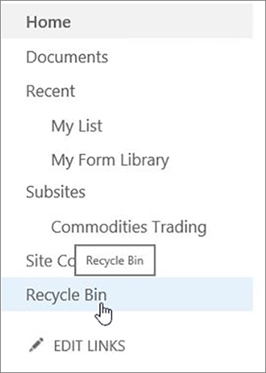

If you don't see the Recycle Bin, follow these steps:

Click Settings and then click Site settings.

Click Recycle bin under Site Collection Administration.

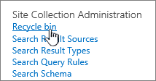

At the bottom of the Recycle Bin page, click second-stage recycle bin.

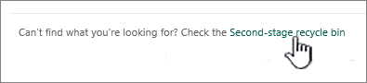

Note: You need administrator or owner permissions to use the site collection Recycle Bin. If you don't see it, it might have been disabled or you don't have permission to access it.

Point to the items you want to restore, click the check icon to the right of each one, and then click Restore.

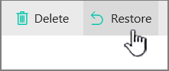

Restore site from Site Admin Recycle Bin

Sign in to Office 365 as a global admin or SharePoint admin.

Select the app launcher icon in the upper-left and choose Admin to open the Office 365 admin center. (If you don't see the Admin tile, you don't have Office 365 administrator permissions in your organization.)

In the left pane, choose Admin centers > SharePoint.

On the ribbon, click Recycle Bin.

In the Recycle Bin, select the check box next to the site collection that you want to restore.

On the ribbon, click Restore Deleted Items.

Restore site from Microsoft Backup

Op Center will obtain time and date site was still known good and site required to be restored.

Op Center will advise team anything updated after that point will be gone.

Op Center will submit a premier Microsoft Ticket on http://premier.microsoft.com

Submit as a Severity B Office Hours only.

In the ticket, request site restoration, date and time.

Microsoft will contact you to sign off on the site restoration and will contact again when restoration is complete.

Op Center will validate the site is as expected with site owners.

Op Center will then close the premier ticket and the Service Now ticket.

Post Implementation Verification/Testing
Errors with deleting certain individuals will occur when Sharegate tries to delete a current user that is still in the system. This is to be expected. Any other errors will need to be reviewed.

Document Revision History

Version | Date | Prepared By | Comment
0.1 | 07/27/2018 | Matthew Kostak | Initial Draft
0.2 | 07/27/2018 | Matthew Kostak | Reviewed with Graham Monteleone
1.0 | 04/02/2018 | Matthew Kostak | Approved for Operation

